**Change from Core to full GUI and back**

**Start with Core installation**

When you start with a server core installation the GUI feature is not located on the HDD so it has to be installed using media (the sxs folder from the installation disc)

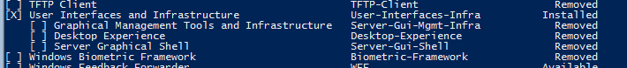

To install the full gui you must first make sure the sxs folder from a Windows 2012/2012 R2 OS is available to you in a local folder or a file share or you have the install disc in the server. In my case I have an ISO mounted and I have to get the sxs folder from the install.wim image.

First find out what indexes the image has so you know to mount the index that contains the graphical binaries.

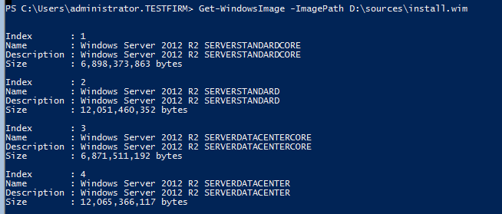

Indexes 2 and 4 are the ones we are looking for. Let’s mount the 2nd index. Make a folder to mount it and use the Mount-WindowsImage command. ReadOnly is needed because the install.wim is on a DVD and cannot be modified.

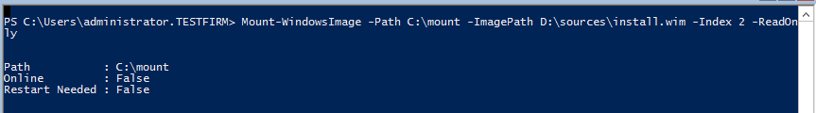

Install-WindowsFeature Server-Gui-Shell -Source C:\mount\Windows\winsxs

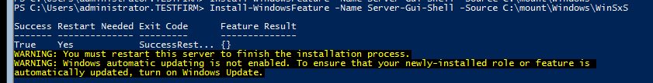

D: is the actual Windows installation disc. A shared folder where the sxs folder is copied can also be used.

After a restart you will have the full GUI.

**Start with GUI installation**

If you install the server with the full GUI and want to switch to Core you have to run a single command:

Remove-WindowsFeature Server-Gui-Mgmt-Infra,Server-Gui-Shell

Add –Remove to completely remove the binaries from the HDD. (if you do this you will need the WinSXS folder from an installed server or from the install.wim on the installation disc to get them back)